**HTTP methods with POST request:**

I created a collection level variable with the Api key of my postman .

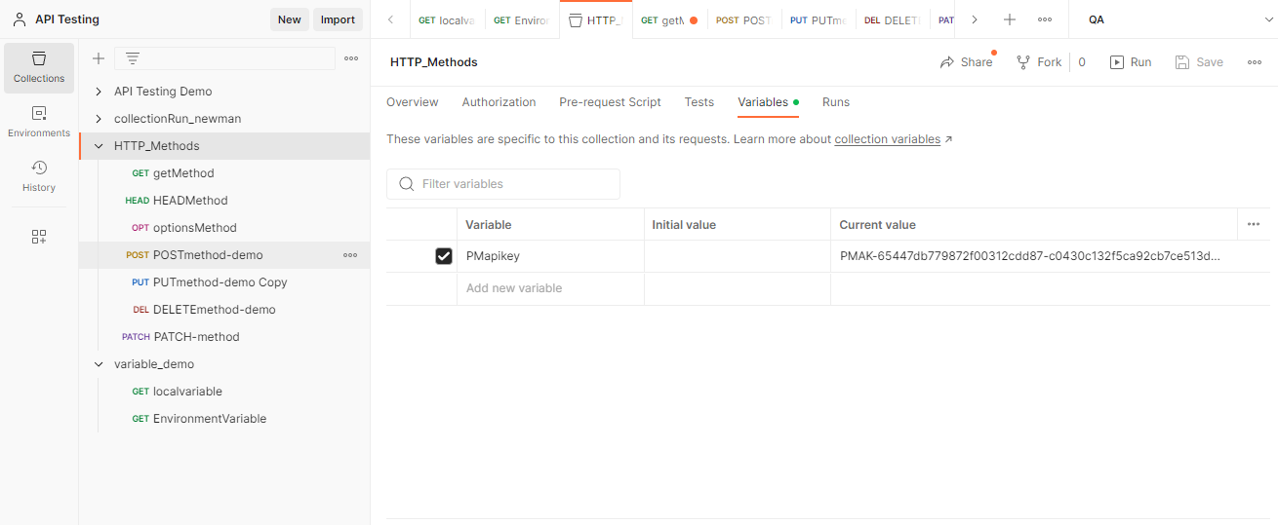

**Get method**: From URL its going to fetch the data.

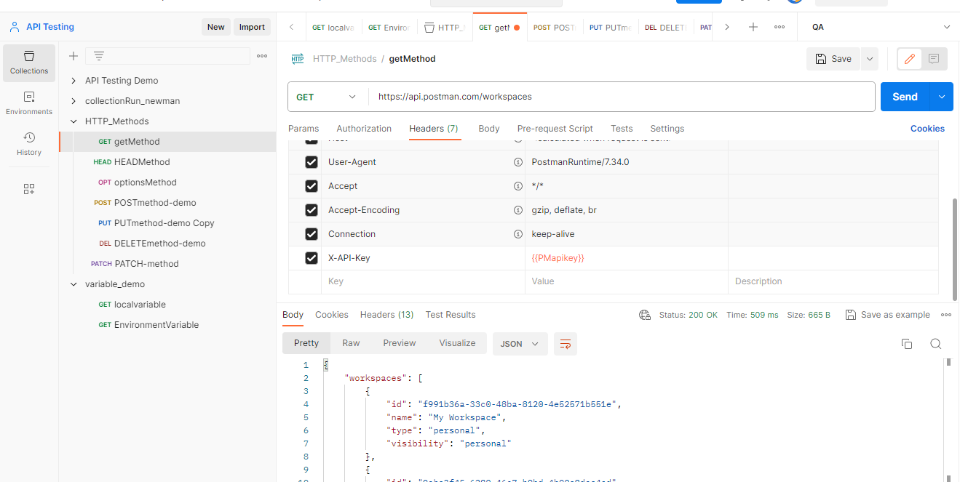

**Head method:** It contains only headers and no body.

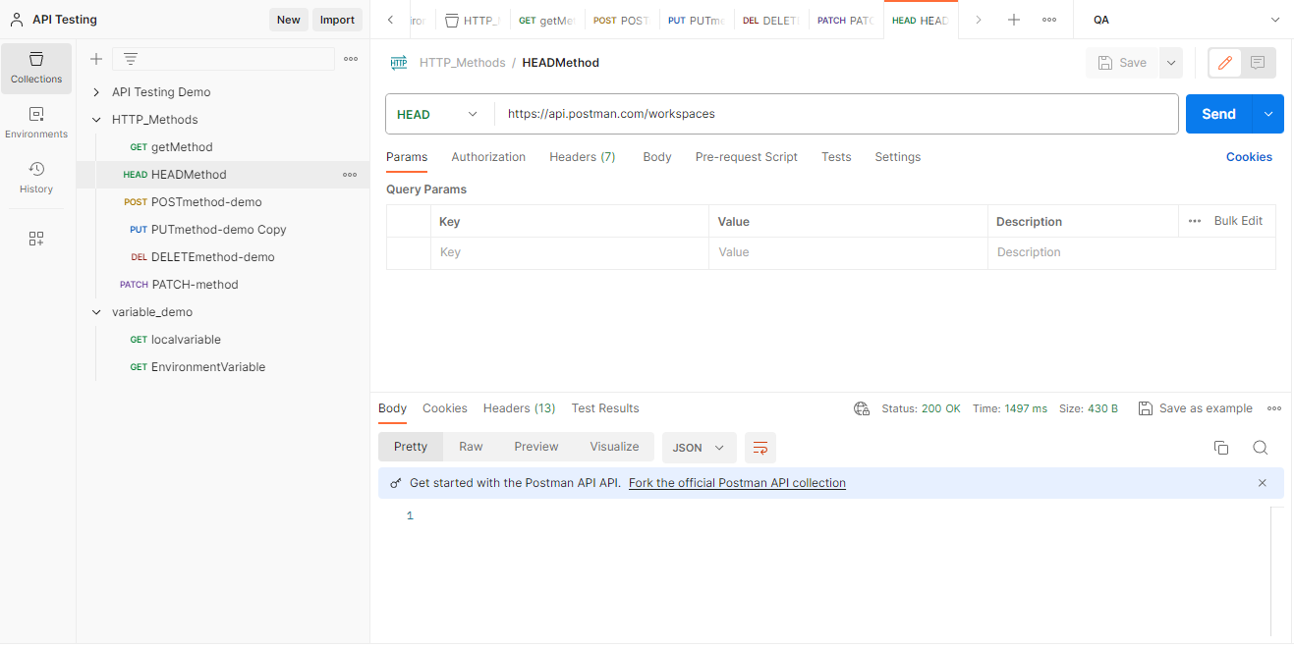.

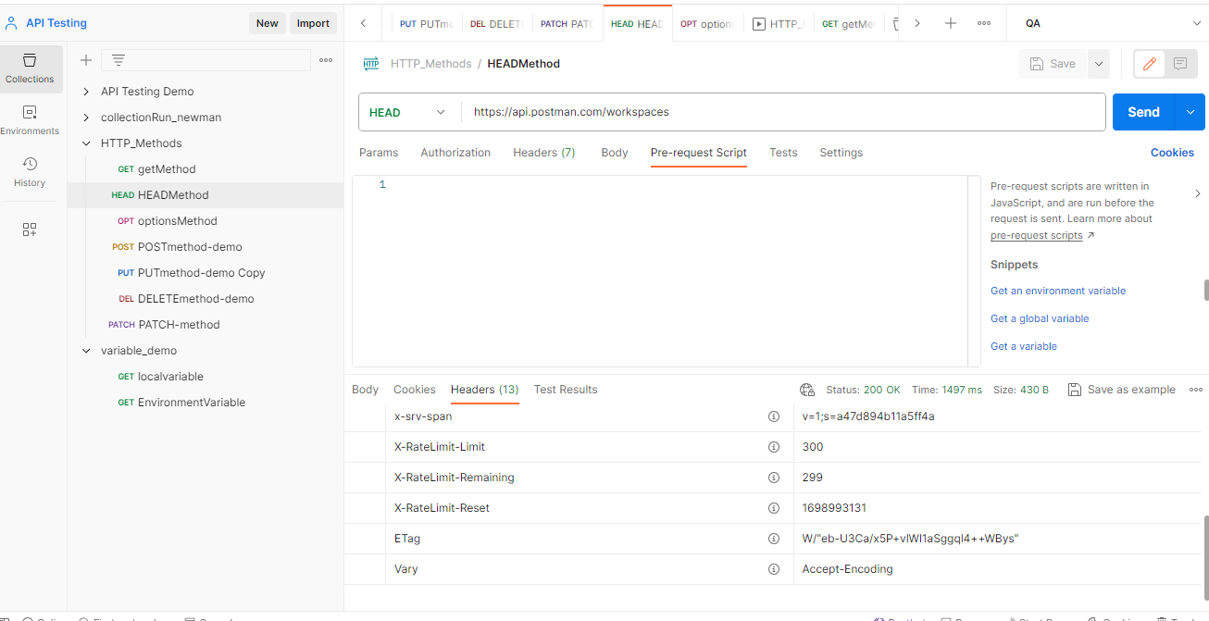

**Options method:** Same as header it wont contain body only options.

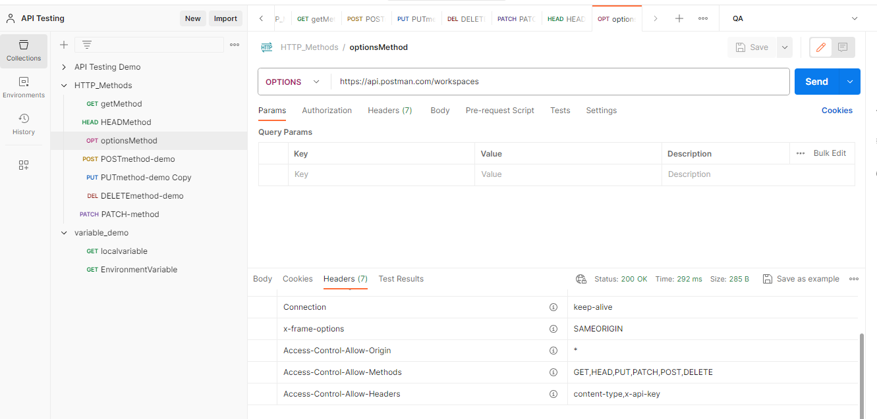

**Post method:** POST request method requests that a web server accept the data enclosed in the body of the request message, most likely for storing it.

Post method I used below to create new Workspace ,The workspace is created.

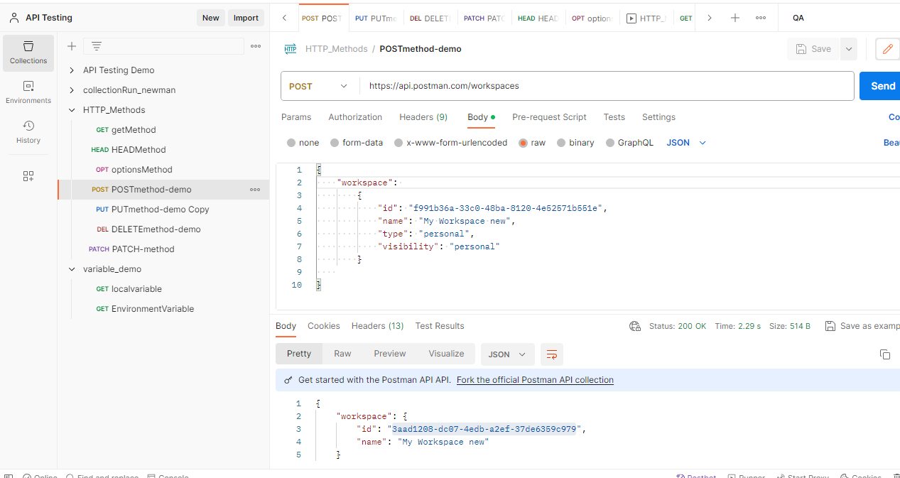

**Put method:** A Postman PUT request is used to pass data to the server for the creation or modification of a resource.

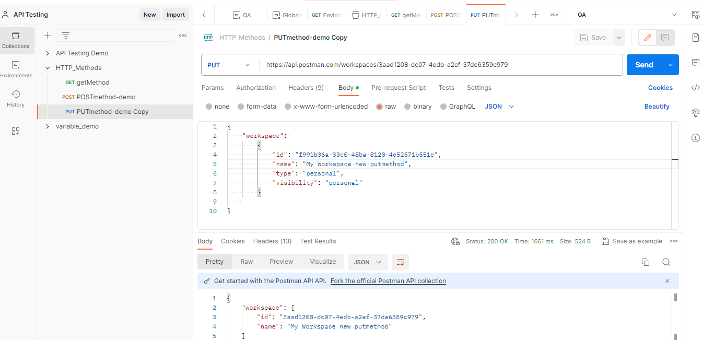

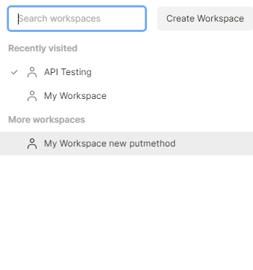

**Delete method:** As given below by using del method I deleted the existing workspace.

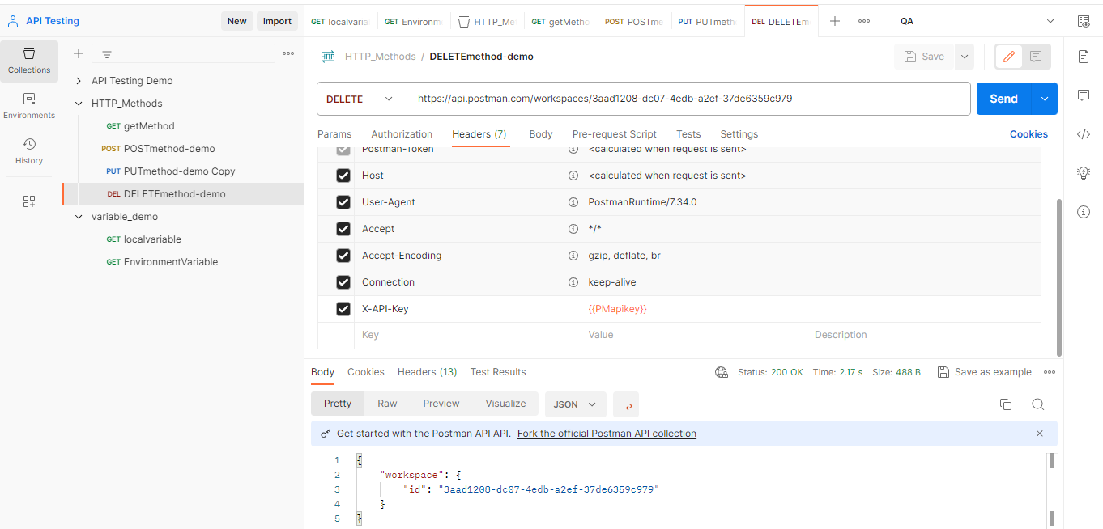

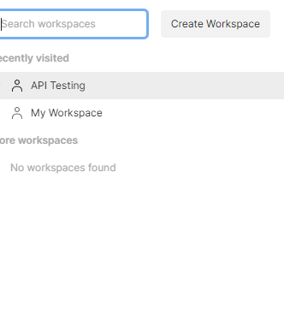

**Patch method:** PATCH method is used to update an existing resource. Its same like put but we don’t need to provide full data to change for patch.

